Sample question:
Suppose that Alice's RSA public key is (N, e) = (33,3) and her private key is d = 7.
a. If Bob encrypts the message M = 19 using Alice's public key, what is the ciphertext CI Show that Alice can decrypt C to obtain M.

Answer:

🔐 RSA Encryption & Decryption
Encryption: C = Me mod N
Decryption: M = C^{d} mod N
✉️ Encryption:
C = Me mod N
= 19³ mod 33
= 6859 mod 33
= 28
👉 C = 28

🔓 Decryption:
M = C^{d} mod N
= 28⁷ mod 33
= 28³ * 28³ * 28 mod 33
= 7 * 7 * 28 mod 33
= 19

✅ Final Answer:
M = 19

Let p=11 and q=13. Compute the modulus N, Euler’s totient ϕ(N), and find a valid public key exponent e such that gcd(e,ϕ(N))=1.
Given:
p = 11, q = 13
Step 1: Compute Modulus NNN
N=p×q=11×13=143
👉 N = 143
Step 2: Compute Euler’s Totient ϕ(N)
ϕ (N)=(p−1)(q−1)=(11−1)(13−1)=10×12=120
ϕ(N) = 120

Step 3: Choose Public Exponent e
Condition:
gcd(e,ϕ(N))=1
👉 এমন একটা e নিতে হবে যেটা 120 এর সাথে co-prime
Possible values:
- e = 7 ✅ (কারণ gcd(7,120) = 1)
- e = 11 ❌ (gcd ≠ 1)
👉 তাই আমরা নেই:

✔️ e = 7
Final Answer
✔️ N=143N = 143N=143
✔️ ϕ (N)=120
✔️ Valid public exponent: e = 7
👉 Public Key হবে: (N, e) = (143, 7)
Co-Prime ber korar technique:
gcd(e,120)=1
👉 মানে: e এবং 120 co-prime হতে হবে

🔹 Step 1: 120 এর prime factor বের করি
120=23×3×5120=23×3×5
👉 তাই e 2, 3, 5 দিয়ে divisible হওয়া যাবে না

🔹 Step 2: Possible e values (small numbers থেকে)
চেক করি:
- 2 ❌ (2 দিয়ে যায়)
- 3 ❌ (3 দিয়ে যায়)
- 4 ❌ (2 আছে)
- 5 ❌
- 6 ❌
- 7 ✅
- 8 ❌
- 9 ❌
- 10 ❌
- 11 ✅
- 12 ❌
- 13 ✅

Using the RSA public key (N=143,e=7), encrypt the message M=10. Show all steps
Given:
N = 143, e = 7
M = 10

🔐 Formula:
C=Me mod N

✉️ Step 1: Compute 10⁷
10⁷=10000000
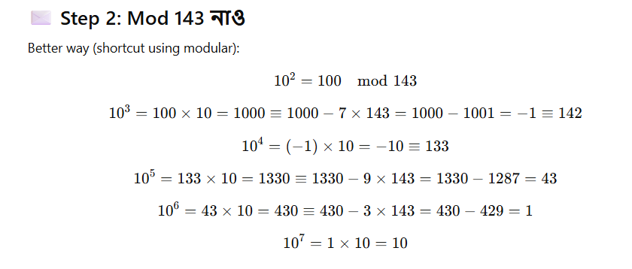

🎯 Final Answer:
Ciphertext C = 10

RSA Decryption Using the private key d=103 and modulus N=143, decrypt the ciphertext C=100. Show the complete calculation.
Solve koro
Diffie-Hellman Key Exchange Alice an d Bob use the Diffie-Hellman key exchange with p=23 and g=5. If Alice selects her private key a=6 and Bob selects b=15, compute the shared secret key K.
Given:
p = 23, g = 5
Alice: a = 6
Bob: b = 15
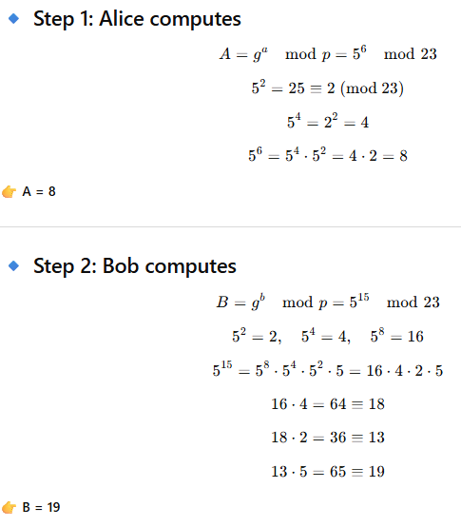

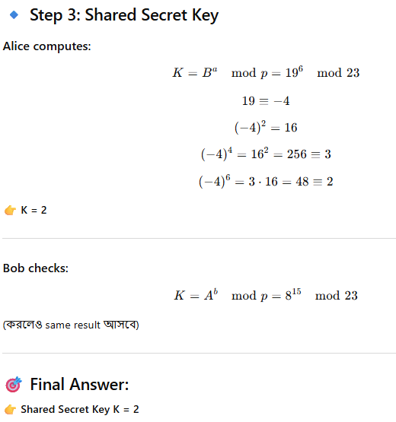
Knapsack Encryption Given the superincreasing knapsack (2,3,7,14), a modulus n=31, and a multiplier m=5, compute the general knapsack.
Given:
Superincreasing knapsack: (2, 3, 7, 14)
n = 31, m = 5

🔐 Formula:
W′=W×m mod n

🔹 Step-by-step calculation:
2×5=10mod 31=10
3×5=15mod 31=15
7×5=35mod 31=4
14×5=70mod 31=8
👉 General Knapsack (Public Key)
(10,15,4,8)
Knapsack Decryption Using the general knapsack (10,15,5,8) and ciphertext C=23, decrypt the message to retrieve the binary sequence.

✅ Method 2: Systematic (Largest → Smallest approach)
Knapsack: (10, 15, 5, 8)
👉 আগে descending order এ সাজাও:
(15, 10, 8, 5)
Target: 23

Step-by-step:
👉 1. 15 নাও
Remaining = 23 − 15 = 8
👉 2. 10 নেওয়া যাবে?
না (8 < 10) ❌
👉 3. 8 নাও
Remaining = 8 − 8 = 0 ✅
👉 কাজ শেষ (remaining = 0)

এখন mapping back করো original order এ:
Original: (10, 15, 5, 8)
- 10 → 0
- 15 → 1
- 5 → 0
- 8 → 1

🎯 Final Answer:
Binary sequence = 0101
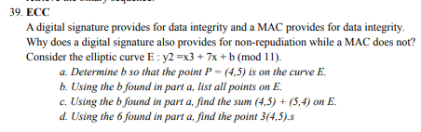
Sample question:
Suppose that for the knapsack cryptosystem, the super increasing knapsack is (3,5,12,23) with n = 47 and m = 6.
a. Give the public and private keys.
b. Encrypt the message M = 1110 (given in binary). Give your result in decimal.
Answer:

🧠 Given:
👉 Superincreasing knapsack (SIK):
(3, 5, 12, 23)
👉 n = 47, m = 6
👉 Message: M = 1110 (binary)

🅰️ (a) Public Key & Private Key

🔐 Step 1: Private Key
👉 Rule:
Private key =
✔️ SIK + m + n
👉 তাই:
✅ Private Key = (3, 5, 12, 23), m = 6, n = 47

🔓 Step 2: Public Key বের করি
👉 Formula:
W' = W × m mod n

এক এক করে করি:
👉 3 × 6 = 18 mod 47 = 18
👉 5 × 6 = 30 mod 47 = 30
👉 12 × 6 = 72 mod 47 = 25
👉 23 × 6 = 138 mod 47 = 44
✅ Public Key = (18, 30, 25, 44)

🅱️ (b) Encryption

🔐 Step 3: Binary message বুঝো
👉 M = 1110
মানে:
Bit | Weight
1 | 18
1 | 30
1 | 25
0 | 44
👉 শুধু যেগুলা 1 আছে সেগুলা যোগ করো:
= 18 + 30 + 25
= 73

✅ Final Answer:

✔️ (a)
- Private Key: (3, 5, 12, 23), m = 6, n = 47
- Public Key: (18, 30, 25, 44)

✔️ (b)
👉 Ciphertext = 73 (decimal)
🔹 What is Cryptography?
Cryptography is the practice of transforming information (messages) so that only authorized people can understand it.

🔹 Main Functions:
- Encryption: Convert plaintext → ciphertext
- Decryption: Convert ciphertext → plaintext

🔹 Purpose of Cryptography:
- Confidentiality: Keep the information secret
- Integrity: Ensure data is not altered
- Authentication: Verify the sender’s identity
- Non-repudiation: Prevent the sender from denying sending the message

🎒 Knapsack Problem কী?
Knapsack problem হলো একটি subset sum problem।
👉 Definition:
দেওয়া থাকে কিছু weight:
W₀, W₁, ..., Wₙ₋₁
এবং একটি sum S

What is RSA?
RSA is a public-key cryptography algorithm, which means it uses two keys:
- Public Key – for encryption (anyone can use it)
- Private Key – for decryption (only the owner can use it)
It’s called the gold standard of public-key crypto because it’s widely used for secure communication.

